COUNCIL ASSESSMENT REPORT
Panel Reference | PPSSEC-205
DA Number | DA/2022/0318
LGA | Inner West Council
Proposed Development | Alterations and additions to an existing school
Street Address | 194-210 Wardell Road Marrickville
Applicant/Owner | Robinson Urban Planning Pty Ltd / Maronite Sisters Holy Family
Date of DA lodgement | 5 May 2022
Total number of Submissions  Number of Unique Objections | Total: 53  Unique: 35
Recommendation | Approval
Regional Development Criteria Schedule 6 of SEPP (Planning Systems) 2021 | Private infrastructure and community facilities over $5 million
List of all relevant s4.15(1)(a) matters | - State Environmental Planning Policy (Resilience and Hazards) 2021  - State Environmental Planning Policy (Transport and infrastructure) 2021  - State Environmental Planning Policy (Biodiversity and Conservation) 2021  - State Environmental Planning Policy (Planning Systems) 2021  - Marrickville Local Environmental Plan 2011  - Marrickville Development Control Plan 2011  - Draft Inner West Local Environmental Plan 2020
List all documents submitted with this report for the Panel’s consideration | - Architectural plans  - Section 4.6 variation request  - Traffic Impact Assessment Report  - Green Travel Plan
Clause 4.6 requests | - Marrickville Local Environmental Plan 2011 – Section 4.3 Height of buildings  - SP2 Infrastructure (Educational Establishments)
Summary of key submissions | - Traffic and parking  - Loss of flora and fauna  - Privacy  - Noise  - Amenity impacts  - Bulk and scale  - Stormwater runoff  - Non-compliance with maximum building height  - Impacts to existing heritage brick boundary fence  - Timeframe for construction and expansion
Report prepared by | Keeley Samways
Report date | 8 March 2023
Summary of s4.15 matters  Have all recommendations in relation to relevant s4.15 matters been summarised in the Executive Summary of the assessment report? |  | Yes
Legislative clauses requiring consent authority satisfaction  Have relevant clauses in all applicable environmental planning instruments where the consent authority must be satisfied about a particular matter been listed, and relevant recommendations summarized, in the Executive Summary of the assessment report?  e.g. Clause 7 of SEPP 55 - Remediation of Land, Clause 4.6(4) of the relevant LEP |  | Yes
Clause 4.6 Exceptions to development standards  If a written request for a contravention to a development standard (clause 4.6 of the LEP) has been received, has it been attached to the assessment report? |  | Yes
Special Infrastructure Contributions  Does the DA require Special Infrastructure Contributions conditions (S7.24)?  Note: Certain DAs in the Western Sydney Growth Areas Special Contributions Area may require specific Special Infrastructure Contributions (SIC) conditions |  | No
Conditions  Have draft conditions been provided to the applicant for comment?  Note: in order to reduce delays in determinations, the Panel prefer that draft conditions, notwithstanding Council’s recommendation, be provided to the applicant to enable any comments to be considered as part of the assessment report |  | Yes


DEVELOPMENT ASSESSMENT REPORT
Value of works |  | $34,036,480.00
Attachment A |  | Architectural plans
Attachment B |  | Section 4.6 variation request
Attachment C |  | Traffic Impact Assessment Report
Attachment D |  | Green Travel Plan
Attachment E |  | Recommended conditions of consent
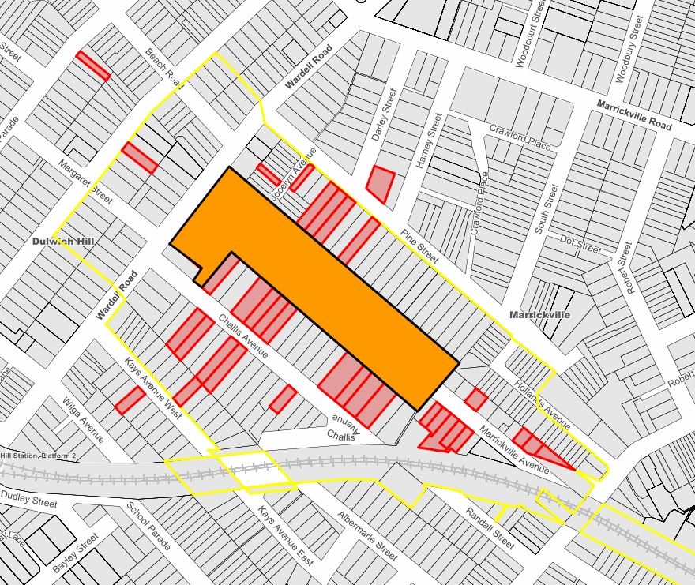
Locality Map

Subject Site |  |  | Objectors |  | N
Notified Area |  |  |  |  | N
Note: Due to scale of map, not all objectors could be shown.

- Executive Summary

This report is an assessment of the application submitted to Council for alterations and additions to the existing school at 194-210 Wardell Road, Marrickville NSW 2204. The application was notified to surrounding properties and 53 submissions were received in response to the notification.

The main issues that have arisen from the application include:

- Non-compliance with the maximum height of buildings development standard;
- Traffic and parking; and
- Submissions.

During the assessment of the application, amended plans and supporting documentation was requested by Council to address a number of issues as discussed in this report. It is considered the additional supporting documentation and amendments to the application address a number of previous concerns raised. The proposal as amended is considered to satisfy the aims, objectives, and design parameters contained in the relevant State Environmental Planning Policies, Marrickville Local Environmental Plan 2011, and Marrickville Development Control Plan 2011. In this regard, the application is considered supportable and in view of the circumstances, it is recommended for approval.

2. Proposal

The subject application proposes alterations and additions to an existing school at 194-210 Wardell Road. The site is currently occupied by numerous buildings and uses, including a convent and chapel, pond, preschool, primary school, secondary school, and residential care facilities. The works proposed under the current application relate to the secondary school, which is located towards the centre of the site, as well as minor works within the front setback and the rear (see Fig. 1 below).

Specifically, the following works are proposed:

- Reconfiguration of the existing parking area within the front setback adjacent to Wardell Road to include 13 car parking spaces, 24 bicycle parking spaces, 2 motorcycle parking spaces, a new pedestrian entrance, and new metal fence to an existing bin enclosure;
- Alterations and additions to existing hall/library to include a new canteen, maintenance room, and library on the ground floor and a hall with indoor basketball court, foyer, and back-of-house facilities at the upper floor;
- Alterations and additions to existing Block A, including reconfiguration of teaching spaces on the ground and first floor and provision of a lift;
- Alterations and additions to existing Block B, including reconfiguration of teaching spaces on the ground and first floor, provision of a new balcony to the first floor north-eastern elevation, and provision of a lift adjacent to Block B corridor;
- Alterations and additions to existing Block C, including reconfiguration of teaching spaces on the ground and first floor;
- Alterations and additions to existing Block D, including reconfiguration of teaching spaces on the ground and first floor, and extension of the first floor to the south-west corner;
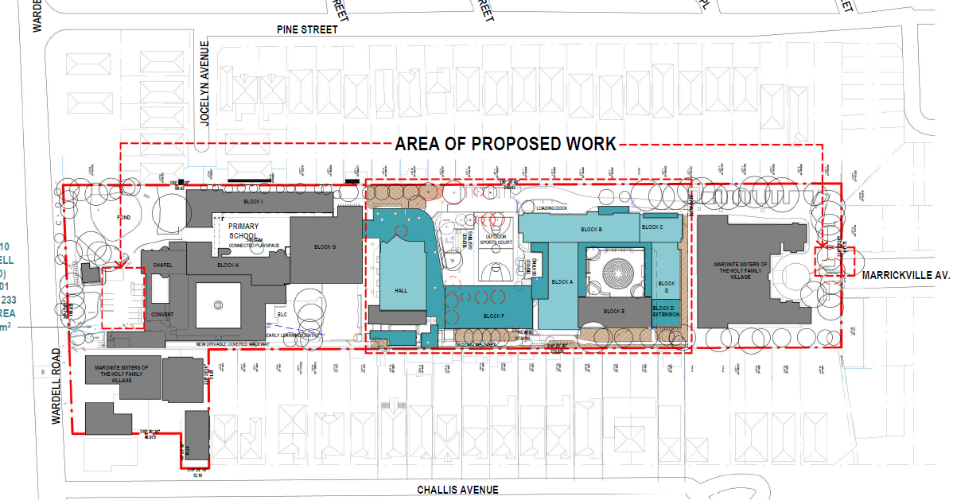Figure 1: Site plan of proposed development showing area of works in blue (centre) and dashed red (left and right).

- New roof to existing Block E;
- Demolition of existing Block F and construction of new two storey Block F comprising teaching spaces on the ground floor and offices and staff facilities on the first floor;
- Widening of the existing driveway off Marrickville Avenue to accommodate manoeuvring of a semi-rigid vehicle, including widening of and alterations to the existing fence and a new gate;
- Replacement of existing outdoor basketball court;
- New covered walkways and ramps;
- New car parking area located towards the centre of the site adjacent to the north-eastern side boundary and accessed via Marrickville Avenue comprising 8 car parking spaces;
- Removal of 13 trees with 26 replacement trees; and,
- Landscaping works throughout the site.

The application also proposes to increase the total number of students by 150, from 500 to 650, as well as to increase the total number of staff by 7, from 51 to 58. It is noted that the application originally proposed an increase to 800 students and 66 staff; however, the proposal was subsequently amended in response to a request for information from Council.

The proposal includes 11 additional car parking spaces on the site (resulting in a total of 37 spaces), 56 additional bicycle parking spaces (resulting in a total of 94 spaces), and two (2) motorcycle parking spaces.

The proposed expansion and works are proposed to occur over a period of 15 years and 9 stages as demonstrated in Table 1 and Figure 2 below.

Table 1: Proposed annual student and staff growth.

Year | Students |  |  | Staff |  |  | Staff total FTE
Year | Primary | Secondary | Total | F/T | P/T | Total | Staff total FTE
2022 | 253 | 243 | 496 | 39 | 12 | 51 | 45.4
2023 | 261 | 252 | 513 | 40 | 12 | 52 | 45.4
2024 | 263 | 259 | 522 | 40 | 12 | 52 | 46.4
2025 | 263 | 267 | 530 | 41 | 11 | 52 | 46.4
2026 | 265 | 275 | 540 | 41 | 11 | 52 | 46.4
2027 | 265 | 303 | 568 | 41 | 11 | 52 | 46.4
2028 | 265 | 310 | 575 | 44 | 8 | 52 | 48.2
2029 | 270 | 317 | 587 | 44 | 8 | 52 | 48.2
2030 | 270 | 324 | 594 | 44 | 8 | 52 | 48.2
2031 | 270 | 331 | 601 | 46 | 6 | 52 | 50
2032 | 270 | 338 | 608 | 46 | 6 | 52 | 50
2033 | 270 | 345 | 615 | 46 | 6 | 52 | 50
2034 | 275 | 352 | 627 | 48 | 5 | 53 | 52.4
2035 | 275 | 359 | 634 | 49 | 5 | 54 | 52.4
2036 | 275 | 366 | 641 | 51 | 7 | 58 | 56.6
2037 | 275 | 375 | 650 | 51 | 7 | 58 | 56.6

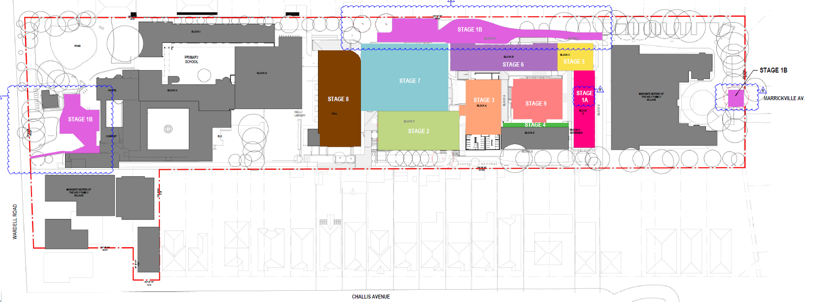
Figure 2: Proposed staging diagram.

3. Site Description

The subject site is located on the south eastern side of Wardell Road, between Pine Street and Challis Avenue, Marrickville. The site consists of one (1) allotment and is generally rectangular is shape with a total area of 26,490 sqm and is legally described as 194-210 Wardell Road, Marrickville.

The site has a primary frontage to Wardell Road of 108.425 metres, a secondary frontage of 12.19 metres to Challis Avenue, and a rear frontage of 61.775 metres to Marrickville Avenue.

The site is currently occupied by a number of buildings and uses, which includes a convent and chapel, preschool (St Maroun’s Preschool), combined primary and secondary school (St Maroun’s College), and residential care facilities (Maronite Sisters of the Holy Family Village). The convent and chapel are listed as a local heritage item, being I27 – Maronite Sisters Convent and High School (former Carmelite Covent).

The site currently comprises two land use zones. The majority of the site, which comprises the convent and chapel, educational establishments, and a residential care facility, are zoned SP2 Infrastructure (Educational Establishment), while the north-western corner of the site, which comprises a residential care facility, is zoned R2 Low Density Residential.

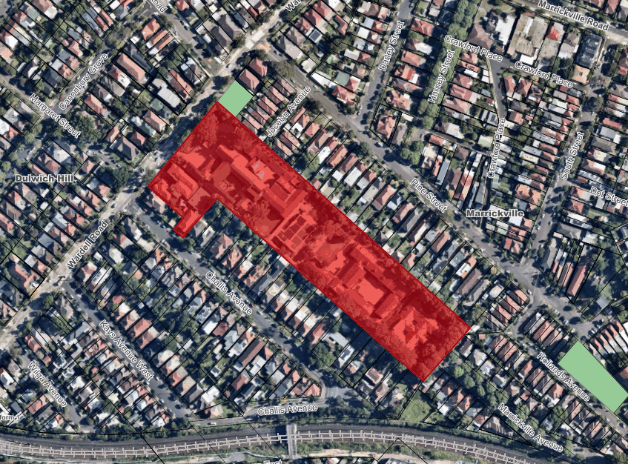 | 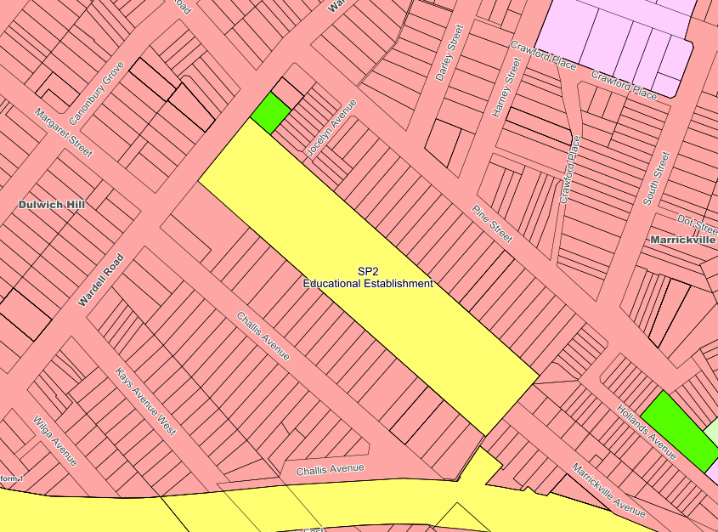
Figure 3: Aerial map | Figure 4: Zoning map

4. Background

4(a) Site history

The following outlines the relevant development history of the subject site:

Application | Application Details | Outcome
HEC/2021/0181 | Installation of 3 signage boards to external wall | Withdrawn  02/05/2022
PDA/2021/0411 | Alterations and additions to existing educational establishment | Advice issued  21/12/2021
HEC/2021/0074 | Signage to external walls | Approved  06/07/2021
DA/2020/0449 | To carry out internal alterations and additions to existing staff rooms, reception, meeting rooms and amenities | Approved  05/08/2020
DA/2020/0241 | Installation of solar photovoltaic system on the roof of St Maroun’s College | Withdrawn  30/10/2020
CDC201400036 | Installation of fire sprinklers and associated works at the existing aged care facility | Approved  09/04/2014
DA201000186 | To carry out works to improve the playground areas of St Maroun’s College including the construction of a basketball court, new paving and seating, upgrading of existing playground areas and new covered walkways | Approved  27/07/2010
DA200700429 | To erect an advertising panel at the front of the property | Approved  10/10/2007
DA200700132 | To construct a new verandah at the rear of the existing aged care facility | Approved  29/03/2007

4(b) Application history

The following table outlines the relevant history of the subject application.

Date | Discussion / Letter / Additional Information
18 October 2022 | Council requested that additional information and/or amended plans be submitted by the applicant to address the following matters:  - Traffic and parking.  - Tree removal.  - Clarification of building heights.  - Clarification of gross floor area.  - Amended Section 4.6 variation request.  - Amended Acoustic Report.  - Privacy treatments.  - Clarification and/or amendment of application details.  - Submissions.
22 December 2022 | The following additional information and/or amended plans were submitted by the applicant via the NSW Planning Portal:  - Acoustic Statement.  - Construction Noise Management Plan.  - Cover letter.  - Existing travel audit.  - Senior students driving policy.  - Details of student and staff numbers.  - Mechanical Statement.  - Revised Acoustic Assessment.  - Revised Arborist Report.  - Revised Section 4.6 variation request.  - Revised architectural plans.  - Revised Green Travel Plan.  - Revised landscape plans.  - Revised Traffic Impact Statement.

5. Assessment

The following is a summary of the assessment of the application in accordance with Section 4.15 of the Environmental Planning and Assessment Act 1979 (EPA Act 1979).

5(a) Environmental Planning Instruments

The application has been assessed against the relevant Environmental Planning Instruments listed below:

- State Environmental Planning Policy (Resilience and Hazards) 2021
- State Environmental Planning Policy (Transport and Infrastructure) 2021
- State Environmental Planning Policy (Biodiversity and Conservation) 2021
- State Environmental Planning Policy (Planning Systems) 2021

The following provides further discussion of the relevant issues:

5(a)(i) State Environmental Planning Policy (Resilience and Hazards) 2021

Chapter 4 Remediation of land

Section 4.16 (1) of the SEPP requires the consent authority not consent to the carrying out of any development on land unless:

“(a) it has considered whether the land is contaminated, and
(b) if the land is contaminated, it is satisfied that the land is suitable in its contaminated state (or will be suitable, after remediation) for the purpose for which the development is proposed to be carried out, and
(c) if the land requires remediation to be made suitable for the purpose for which the development is proposed to be carried out, it is satisfied that the land will be remediated before the land is used for that purpose.”

In considering the above, there is no evidence of contamination on the site.

There is also no indication of uses listed in Table 1 of the contaminated land planning guidelines within Council’s records. The land will be suitable for the proposed use as there is no indication of contamination.

5(a)(ii) State Environmental Planning Policy (Transport and Infrastructure) 2021

Chapter 2 Infrastructure

Section 2.98 Development adjacent to rail corridors

The proposed development was referred to the rail authority in accordance with Section 2.98 of SEPP (Transport and Infrastructure) 2021. Transport for NSW (TfNSW) (Sydney Trains) did not raise any objections to the proposed development, subject to the imposition of suitable conditions of consent, which have been included in the recommendation. In this regard, it is considered that the proposed development satisfies the provisions of this Section.

Section 2.118 Development on proposed classified road

Vehicular access to the land is currently provided via Wardell Road (primary frontage) and Marrickville Avenue (rear frontage). The subject development does not propose to alter the current vehicular access configurations, and as such this is considered practical and safe. The design will not adversely impact the safety, efficiency, and ongoing operation of the classified road.

Furthermore, the application was referred to TfNSW who did not raise any objections to the proposed development.

Chapter 3 Educational establishments and childcare facilities

The proposal does not rely on Section 3.15 for permissibility of SEPP (Transport and Infrastructure) 2021.

Section 3.36(6) of the SEPP requires the consent authority to take the following into consideration:

- the design quality of the development when evaluated in accordance with the design quality principles set out in Schedule 8, and
- whether the development enables the use of school facilities (including recreational facilities) to be shared with the community.

The following is an assessment against the seven design quality principles in referred to in part (a) and addresses part (b):

Principle | Comment | Compliance
1 – context, built form and landscape | The proposal generally satisfies the principle as follows:  - The proposal has been designed to respond to and enhance the positive qualities of its setting, landscape, and heritage; and  - The proposal integrates landscaping into the design of the development to enhance amenity and mitigate negative impacts to neighbouring sites. | Yes
2 – sustainable, efficient and durable | The proposal generally satisfies the principle as follows:  - The proposal has been appropriately designed to be durable, resilient, and adaptable. | Yes
3 – accessible and inclusive | The proposal generally satisfies the principle as follows:  - Appropriate access is provided to the building for people with differing needs and capabilities; and  - The college grounds are currently shared with the local community and are used outside of school hours for various activities. | Yes
4 – health and safety | The proposal generally satisfies the principle as follows:  - The proposal has been designed to optimise health, safety, and security. | Yes
5 – amenity | The proposal generally satisfies the principle as follows:  - The proposal provides pleasant and engaging spaces; and  - The proposal includes appropriate, efficient, stage, and age appropriate indoor and outdoor leaning and play spaces. | Yes
6 – while of life, flexible and adaptive | The proposal generally satisfies the principle as follows:  - The proposal does not preclude the future adaptation of the buildings. | Yes
7 – aesthetics | The proposal generally satisfies the principle as follows:  - The proposal is aesthetically pleasing and incorporates a built form that has good proportions and a balanced composition of elements;  - The proposal has a positive impact on the quality and character of the neighbourhood; and  - The proposal responds to the existing and desired future character of the area. | Yes

5(a)(iii) State Environmental Planning Policy (Biodiversity and Conservation) 2021

Chapter 2 Vegetation in non-rural areas

The protection and removal of vegetation identified under the SEPP and gives effect to the local tree preservation provisions of Council’s DCP.

The application originally proposed the removal of 26 trees from the site, which was considered to be contrary to the provisions of the SEPP. Accordingly, Council requested that the application be amended to retain more trees. The proposal was subsequently amended to seek the removal of 13 trees, with 26 replacement trees provided.

The application was referred to Council’s Urban Forest Officer, who did not raise any objections to the revised proposal as the canopy analysis indicates no net loss of canopy once the planted replacement trees are mature. Subject to the imposition of conditions of consent that require 26 replacement trees to be planted, the proposal is considered to satisfy the relevant provisions of the SEPP.

5(a)(iv) State Environmental Planning Policy (Planning Systems) 2021

The proposed development is listed under Schedule 6 of the Planning Systems SEPP as being a type of development that is declared to be regionally significant for the purposes of the EPA Act, that being “private infrastructure and community facilities over $5 million”. As such, the application has been referred to the Sydney Eastern City Planning Panel for determination.

5(a)(v) Local Environmental Plans

Inner West Local Environmental Plan 2022

The Inner West Local Environmental Plan 2022 (IWLEP 2022) was gazetted on 12 August 2022. As per Section 1.8A – Savings provisions, of this Plan, as the subject application was made before the commencement of this Plan, the application is to be determined as if the IWLEP 2022 had not commenced.

Section 4.15(1)(a)(i) of the EPA Act 1979 requires consideration of any Environmental Planning Instrument (EPI), and Section 4.15(1)(a)(ii) also requires consideration of any EPI that has been subject to public consultation. The subject application was lodged on 5 May 2022, on this date, the IWLEP 2022 was a draft EPI, which had been publicly exhibited and was considered imminent and certain.

The draft EPI contained the following amended provisions:

- Section 1.2 Aims of Plan – changes to the aims.
- Zone SP2 Infrastructure – changes to the land use objectives.
- Section 4.3 Height of buildings – changes to the development standard objectives.
- Section 6.3 Stormwater management – addition of new Section.

Notwithstanding, the development is considered to generally satisfy the provisions of the Draft EPI and is therefore considered acceptable.

Marrickville Local Environmental Plan 2011 (MLEP 2011)

The application was assessed against the following relevant sections of the Marrickville Local Environmental Plan 2011:

Part 1 – Preliminary

Control | Proposed | Compliance
Section 1.2  Aims of Plan | The proposed development is considered to satisfy the relevant aims of the Plan as follows:  - The proposal supports the efficient use of the land;  - The proposal promotes sustainable transport options;  - The proposal identifies and conserves the heritage of Marrickville; and  - The proposal promotes a high standard of design in the private and public domain. | Yes

Part 2 – Permitted of prohibited development

Control | Proposed | Compliance
Section 2.3  Zone objectives and Land Use Table | The proposal satisfies the section as follows:  - The subject site is zoned SP2 Infrastructure (Educational Establishment) and R2 Low Density Residential. The proposed works subject to this application are contained wholly upon the land that is zone SP2 Educational Establishment;  - The application proposes alterations and additions to an existing school, which is permissible with consent in the SP2 Educational Establishment zone; and  - The development meets the objectives of the zone as it will provide appropriate infrastructure for the existing educational establishment. | Yes
Section 2.7  Demolition requires development consent | The proposal satisfies the section as follows:  - Demolition works are proposed, which are permissible with consent; and  - Standard conditions are recommended to manage impacts which may arise during demolition. | Yes, subject to conditions

Part 4 – Principal development standards

Control | Proposed |  | Compliance
Section 4.3  Height of building | Maximum | J – 9.5m | No – see below
Section 4.3  Height of building | Proposed | 12.04m | No – see below
Section 4.3  Height of building | Variation | 26.7% (2.54m over) | No – see below
It is noted that the maximum building height calculations differ between Council and the applicant.

Council calculates the proposed development breaches the maximum building height development standard at two points:
- The proposed hall – 12.04m, being a 26.7% variation (2.54m over); and
- The lift overrun and southeast corner of Block F – 10.79m, being a 13.6% variation (1.29m over).

The applicant has calculated the following measurements:
- The lift/stair core of Block F – 11.46m, being a 21% variation (1.96m over); and
- The hall – 11.2m, being an 18% variation (1.7m over).

In their submission, the applicant notes that the extrapolation method has been used to calculate the building height:

“The extrapolation method has been used to measure building height. In determining the ground level (existing)¹, multiple survey points were taken across the entire site, which were then extrapolated to a height of 9.5m (as shown on Drawing DA-911 Rev B - 3D View 9.5m Height Plan).

The context of a development site is important whereby existing topography (natural and developed) would result in irregular height planes, and the result would not place the proposed development in context on the site and surrounds.

As such, the extrapolation method was determined to be the most suitable, given the large site area, multiple buildings and structures, in addition to the significant fall across the whole site, whereby excavation has also previously occurred in some parts.

In addition, the proposed altered and new buildings extend beyond the existing buildings footprints. For this reason, the extrapolation method was used in determining the maximum building height”.

In this case, Council does not agree that the extrapolation method is appropriate given the site is not completely built out and there are sufficient existing ground levels on the site to determine “ground level (existing)”. Accordingly, Council argues that the existing ground level should be taken as the existing level of the site at any point. In the case of measuring the existing ground level where there is an existing building, Council notes that the existing level should be taken to be the ground underneath the slab of that building as that is the existing ground level at the time of the proposed development, as opposed to a “pre-existing” or “natural ground” level. It is considered that this method results in a more accurate building height measurement that relates to the subject site.

Notwithstanding, it is acknowledged that the proposal results in a variation to the height of buildings development standard, which is considered with respect to Section 4.6 of MLEP 2011 below.
Section 4.4  Floor space ratio | Maximum | F – 0.6:1 (15,894sqm) | Yes
Section 4.4  Floor space ratio | Proposed | 0.5:1 (13,245sqm) | Yes
Section 4.4  Floor space ratio | Variation | N/A | Yes
Section 4.5  Calculation of floor space ratio and site area | The site area and floor space ratio for the proposal has been calculated in accordance with the section. |  | Yes
Section 4.6  Exceptions to development standards | The applicant has submitted a variation request in accordance with Section 4.6 to vary the Section 4.3 Height of buildings development standard. |  | See below
The applicant seeks a variation to the height of buildings development standard under Section 4.3 of the Marrickville Local Environmental Plan 2011. As noted above, the extent of the variation has been calculated by Council as a maximum of 26.7% (2.54m), and by the applicant as a maximum of 21% (1.96m).

Notwithstanding, Section 4.6 allows Council to vary development standards in certain circumstances and provides an appropriate degree of flexibility to achieve better design outcomes.

In order to demonstrate whether strict numeric compliance is unreasonable and unnecessary in this instance, the proposed exception to the development standard has been assessed against the objectives and provisions of Section 4.6 of the Marrickville Local Environmental Plan 2011 below.

The objectives of the height of building development standard are as follows:

- To establish the maximum height of buildings,
- To ensure building height is consistent with the desired future character of an area,
- To ensure buildings and public areas continue to receive satisfactory exposure to the sky and sunlight,
- To nominate heights that will provide an appropriate transition in built form and land use intensity.

The objectives of the SP2 Infrastructure zone are as follows:

- To provide for infrastructure and related uses.
- To prevent development that is not compatible with or that may detract from the provision of infrastructure.
- To protect and provide for land used for community purposes.

A written request has been submitted to Council in accordance with Section 4.6(4)(a)(i) of the Marrickville Local Environmental Plan 2011 justifying the proposed contravention of the development standard, which is summarised below:

- The protrusion at Block F above the height standard relates to a very small component of the proposed building, necessitated by the functional requirements of the building (to achieve fire and access compliance).
- The height of the hall is governed by minimum internal specifications and clearance heights that must be maintained to ensure that the hall can house competition grade basketball games. As such the height of the hall cannot be lowered without significantly compromising the intent and function of the space. Lowering the height of the building would deprive the College and the local community of a vital piece of community/educational/ sporting infrastructure.
- The remainder of the works within the Development Area (to Block A, Block B, Block C and Block D) are either contained internally or below the existing/proposed roof structures which are below the 9.5m building height standard.
- The non-compliant built form will not be visible from the street, with works located in the centre of the site, out of sight from Wardell Road and Marrickville Lane.
- The non-compliant form is also generally not perceivable from adjacent properties due to the existing 2.3m high solid boundary wall that surrounds the site, increased side setbacks to the new works and the proposed retention of existing established landscaping.
- The non-compliant form will not detract from the heritage items on site as the proposal respects and improves the relationship with heritage items.
- There are no unreasonable overshadowing, privacy, view or noise impacts arising from the contravention, with amendments to the design made during the community consultation phase to address the issues raised by residential neighbours.

The applicant’s written rationale adequately demonstrates compliance with the development standard is unreasonable and unnecessary in the circumstances of the case, and that there are sufficient environmental planning grounds to justify contravening the development standard.

It is considered the development is in the public interest because it is consistent with the objectives of the SP2 Infrastructure (Educational Establishments), in accordance with Section 4.6(4)(a)(ii) of the Marrickville Local Environmental Plan 2011 for the following reasons:

- The proposal provides for educational infrastructure and continues the use of the site for educational purposes.
- It is considered that the proposed development has been appropriately designed and located to be compatible with the site. The development is considered unlikely to detract from or prevent the provision of educational infrastructure on the site in the future.
- The proposal provides an educational use for the community and increases the number of student places available to meet the demands of the community.

It is considered the development is in the public interest because it is consistent with the objectives of the height of buildings development standard, in accordance with Section 4.6(4)(a)(ii) of the Marrickville Local Environmental Plan 2011 for the following reasons:

- The desired future character of the site is educational, while the surrounding area is low density residential. The proposed development maintains the existing and desired future character of the site whilst remaining compatible with the surrounding residential character.
- The proposed works to the buildings are generally modest in scale and provide sufficient building setbacks to mitigate adverse amenity and visual bulk impacts to adjoining properties and as viewed from the public domain.
- The proposed development has been appropriately designed to limit adverse overshadowing and visual bulk impacts to adjoining properties and the public domain. Surrounding buildings will continue to receive satisfactory exposure to sky and sunlight.
- The proposed development is considered to provide an appropriate transition in building form and land use intensity. The proposed buildings are located at an appropriate setback from the property boundaries to reduce adverse amenity, visual bulk, and overshadowing impacts to adjoining properties, and to provide an appropriate transition to the predominantly low density, single and two storey dwellings that adjoin the site.

The concurrence of the Planning Secretary may be assumed for matters dealt with by the Local Planning Panel.

The proposal thereby accords with the objective in Section 4.6(1)(b) and requirements of Section 4.6(3)(b) of the Marrickville Local Environmental Plan 2011. For the reasons outlined above, there are sufficient planning grounds to justify the departure from the height of buildings development standard and it is recommended the Section 4.6 exception be granted.

Part 5 – Miscellaneous provisions

Control | Compliance | Compliance
Section 5.10  Heritage conservation | The subject site is a listed heritage item, namely Maronite Sisters Convent and High School (former Carmelite Convent) (Item No. I17). The site is also located within the South Dulwich Hill Heritage Conservation Area.  The proposed development is considered acceptable as follows:  - There are no proposed works to the significant heritage buildings on the site and the location of the proposed works on the site are physically and visually removed from the significant heritage buildings.  - The rearrangement of the car parking spaces to the Wardell Road car park are considered unlikely to have any physical impact on the chapel or convent.  - The works are located towards the centre of the site and as such their siting, location, scale, and form are considered unlikely to impact on the South Dulwich Hill HCA and their associated views.  - The proposal ensures the continued use of the school site and does not have an adverse impact on the significance of the place.  In this regard, the development has been designed to respond to the significance of the item and conservation area and preserves the environmental heritage of Marrickville. | Yes

Part 6 – Additional local provisions

Control | Proposed | Compliance
Section 6.2  Earthworks | The proposed earthworks are unlikely to have a detrimental impact on environmental functions and processes, existing drainage patterns, or soil stability. | Yes
Section 6.4  Terrestrial biodiversity | The proposed development is considered to satisfy the relevant provisions of this Section as follows:  - The proposal has been appropriately designed, sited, and will be managed to avoid any significant adverse environmental impact;  - The extent of tree removal is considered acceptable, subject to suitable replacement plantings. Appropriate conditions have been included in the recommendation; and  - Standard conditions have been included in the recommendation to ensure there are no adverse impacts to the existing bandicoot population (see discussion under Part 2.13 below). | Yes, subject to conditions

5(d) Development Control Plans

The application has been assessed and the following provides a summary of the relevant provisions of Marrickville Development Control Plan 2011.

Part 2 – Generic Provisions

Control | Proposed | Compliance
Part 2.1 – Urban Design | The proposal satisfies the relevant provisions of this Part as follows:  - The proposal does not impact the definition between the public and private domain and is appropriate for the character of the locality given its form, massing, siting, and detailing;  - The proposal preserves the existing character of the streetscape, as the proposed works will not be visible from the public domain; and  - It is noted that the submitted plans that demonstrate the location of the air conditioner condensers and screening relates to an earlier architectural scheme. Notwithstanding, it appears the condensers have generally been located so as to not impact the streetscape or the architectural integrity of the buildings. A condition has been included in the recommendation requiring these plans to be amended to reflect the correct architectural plans. | Yes, subject to conditions
Part 2.5 – Equity of Access and Mobility | The proposal satisfies the relevant provisions of this Part as follows:  - Appropriate access is provided for all persons through the principal entrance to the premises;  - A Continuous Accessible Path of Travel (CAPT) to and within the subject premises is provide which allows a person with a disability to gain access to all areas within the school;  - One (1) accessible car parking space is provided, which meets the minimum requirements; and  - Suitable accessible sanitary facilities are provided. | Yes
Part 2.6 – Acoustic and Visual Privacy | The proposal satisfies the relevant provisions of this Part as follows:  - Proposed new windows that face onto the adjoining residential properties are provided with appropriate privacy screening to reduce adverse visual and acoustic privacy impacts;  - The application was accompanied by an Acoustic Report, which demonstrates compliance with the relevant acoustic noise criteria. The report also demonstrates that the proposal is unlikely to result in any adverse acoustic impacts to nearby residential properties;  - Conditions have been included in the recommendation to ensure compliance with the relevant acoustic noise criteria;  - The proposal includes appropriate management techniques to limit acoustic impacts to nearby and adjoining residents;  - The application does not propose any changes to the existing hours of operation. | Yes, subject to conditions
Part 2.7 – Solar Access and Overshadowing | The proposal satisfies the relevant provisions of this Part as follows:  - A minimum of 2 hours direct solar access to windows of principal living areas and principal areas of open space of nearby residential properties is retained between 9:00am and 3:00pm on 21 June;  - The development will not result in adverse amenity impacts as a result of overshadowing; and  - The proposal has been appropriately sited and designed to maximise direct solar access to reduce reliance on artificial lighting and heating. | Yes
Part 2.9 – Community Safety | The proposal satisfies the relevant provisions of this Part as follows:  - The principal entrance to the site is visible from the street;  - Communal areas are well defined and have a reasonable level of surveillance; and,  - Unintended and unauthorised access to the site is minimised through the appropriate design and location of built elements and security devices. | Yes
Part 2.10 – Parking | See below. | No – however, acceptable on merit
The site is located in Parking Area 3 per Part 2.10 of MDCP 2011. As such, the proposal is required to provide on-site parking as follows:
Component | Control | Required | Proposed | Complies
Car parking | 1 per 2 staff for staff + drop-off and pick-up facility for parents and carers | 58 staff = 29 spaces | 19 spaces  (11 additional, including 1 accessible parking space)  (37 total on site, including 18 existing spaces  for the residential care facility) | No
Bicycle parking | 1 per 20 staff + 1 per 10 students for students | 58 staff + 650 students = 68 spaces | 94 spaces | Yes
Clothes lockers | 1 per 3 staff spaces + lockers for students on merit | 58 staff = 19 lockers | 24 lockers | Yes
Showers | 1 + extra on merit for staff + showers for students on merit | Min. 1 | 2 showers | Yes
Motorcycle parking | 5% of the total car parking requirement | 1 space | 2 spaces | Yes

As noted in the table above, based on the proposed total number of staff the development is deficient 10 on-site car parking spaces. However, when the parking rates are applied to the proposed increase in staff (i.e. 7 staff), the required number of parking spaces is reduced to four (4).

It is noted that the submitted Traffic Impact Assessment Report (TIA) prepared by Bitzios Consulting also bases the required number of parking spaces on the proposed increase in staff numbers as opposed to the total number of staff members. In this regard, the TIA notes the proposal provides a compliant number of car parking spaces.

Despite the numerical non-compliance, it is considered that the proposal satisfies the relevant objectives of this Part as follows:

- The proposal provides a sufficient number of car parking spaces for the proposed increase in staff numbers. Although the proposal does not comply with the minimum requirement for the proposed total number of staff, the proposal results in an improvement to the existing parking provision.
- The proposal promotes the use of sustainable transport, including walking, cycling, and public transport. The proposal provides bicycle parking spaces in excess of the minimum requirement, and is also located in an accessible area, being less than 400m to Dulwich Hill train station with a number of bus stops also located within proximity to the site.
- The submitted TIA and Green Travel Plan recommend a range of traffic management practices, including a Pick-up/Drop-off Management Plan and a ‘No Drive to School’ policy for senior students, to reduce the impacts of private car trips. Conditions have been included in the recommendation to ensure the adoption of these practices.
- The proposed car parking and internal road works are proposed to be completed as part of Stage 1 of the staging plan. This ensures the additional parking spaces will be available prior to the increase in staff and students.
- The parking provision and design is compatible with the proposed development.
- The proposed parking facilities are safe, functional, and accessible through compliance with design standards.
- Given the site constraints, it is considered that on balance the parking proposed is acceptable.

Given the above, the proposal is considered acceptable with regard to this Part.

Part 2.13 – Biodiversity | The proposal satisfies the relevant provisions of this Part as follows:  - The proposal has been appropriately designed to protect and promote the recovery of threatened species, populations, and endangered ecological communities;  - The site is located in a Bandicoot Protection Area. As such, a Biodiversity Impact Assessment report was submitted with the application, which addresses the provisions of this Part, and which concludes that the proposed development will have negligible impacts on biodiversity; and  - Standard conditions have been included in the recommendation to ensure all workers on site are made aware of the potential presence of bandicoots, appropriate site inspections are conducted, and the steps that should be taken if a bandicoot is found on site. | Yes, subject to conditions
Part 2.18 – Landscaping and Open Spaces | The proposal satisfies the relevant provisions of this Part as follows:  - The proposed landscaping conforms to and complements the character of the site and the area;  - The proposal has been appropriately designed to retain and enhance existing significant trees and planting on the site;  - The proposal improves the appearance, amenity, and energy efficiency of the development through integrated landscaping;  - The proposal incorporates sufficient areas of permeable landscaping to assist with stormwater infiltration and reduce runoff; and  - The proposal provides a vegetated buffer between the adjacent residential uses. | Yes
Part 2.21 – Site Facilities and Waste Management | The proposal satisfies the relevant provisions of this Part as follows:  - The application was accompanied by a waste management plan in accordance with the Part; and  - Standard conditions are recommended to ensure the appropriate management of waste during the construction of the proposal. | Yes, subject to conditions
Part 2.25 – Stormwater Management | The proposal satisfies the relevant provisions of this Part as follows:  - Standard conditions are recommended to ensure the appropriate management of stormwater. | Yes, subject to conditions

Part 8 – Heritage

Control | Assessment | Compliance
Part 8.1.7 – Heritage Items | The proposal satisfies the relevant provisions of this Part as follows:  - There are no proposed works to the significant heritage buildings on the site and the location of the proposed works on the site are physically and visually removed from the significant heritage buildings;  - The development conserves the heritage item and proposes new works that do not diminish the significance of the item; and  - Significant features of the heritage item are maintained in the original form. | Yes

Part 9 – Strategic Context

Control | Assessment | Compliance
Part 9.21 – Ness Park | The proposal satisfies the relevant provisions of this Part as follows:  - The proposal protects the identified heritage item on the site;  - The proposal protects significant streetscape elements as the proposed works are appropriately located so as to not be highly visible from the public domain;  - The proposal supports pedestrian and cyclist access, activity, and amenity;  - The proposal ensures off-street parking does not adversely impact the amenity of the precinct; and  - The proposed protects the identified values of the South Dulwich Hill Heritage Conservation Area. | Yes

5(e) The Likely Impacts

The assessment of the Development Application demonstrates that, subject to the recommended conditions, the proposal will have minimal impact in the locality.

5(f) The suitability of the site for the development

Provided that any adverse effects on adjoining properties are minimised, this site is considered suitable to accommodate the proposed development, and this has been demonstrated in the assessment of the application.

5(g) Any submissions

The application was notified in accordance with the Community Engagement Framework for a period of 30 days to surrounding properties. Fifty-three (53) submissions were received in response to the notification.
The following issues that were raised in submissions have been discussed elsewhere in this report:

- Parking
- Loss of flora and fauna
- Privacy
- Noise
- Amenity impacts
- Bulk and scale
- Out of character
- Stormwater runoff
- Non-compliance with building height

In addition to the above issues, the submissions raised the following concerns:

Concern | Comment
Traffic | Concerns were raised that the increased student and staff numbers, and subsequent parking requirements, could not be appropriately and safely accommodated on the site or surrounding streets, particularly given concerns around existing traffic and parking conditions.  As noted above, the application originally proposed to increase student numbers to 800 and staff numbers to 66. The application was subsequently amended, reducing the proposed increase to 650 students and 58 staff, respectively. In this regard, the expected increase in traffic and parking has reduced. The application was further amended to delete a proposed expansion to the existing drop-off/pick-up area on Wardell Road.  Council’s Development Engineers reviewed the proposed development and accompanying reports, including the Traffic Impact Assessment Report and Green Travel Plan (GTP) prepared by Bitzios Consulting, and an audit of existing travel modes and No Drive Policy (NDP) prepared by St Maroun’s College. Subject to conditions of consent requiring the implementation of the recommendations made in the GTP, and the adoption of the NDP, Council’s Development Engineers were satisfied that traffic and parking impacts can be appropriately managed.
Impacts to existing brick boundary fence | Concerns were raised regarding potential impacts to the existing heritage brick boundary fence located on the boundaries of the site, which adjoins residential properties on Challis Avenue and Pine Street.  The application does not propose any works to the existing fence, except for widening of the entry via Marrickville Avenue. Notwithstanding, conditions have been included in the recommendation requiring the structural adequacy of the wall to be confirmed prior to any works, and that if any damage occurs to the wall during construction that it be appropriately repaired prior to the issue of an Occupation Certificate. A condition requiring a dilapidation report to be prepared for the full extent of the fence adjoining residential properties on Challis Avenue and Pine Street has also been included in the recommendation.
Noise and safety impacts during construction | Concerns were raised regarding access to the site for construction and subsequent adverse impacts to pedestrian safety and amenity impacts to residents.  Conditions of consent have been included in the recommendation requiring a Construction Traffic Management Plan to be implemented to ensure construction is conducted in a safe and appropriate manner; with limited hours for construction to ensure adverse amenity and acoustic impacts to surrounding residential properties are minimised.
Timeframe for construction and expansion | Concern was raised that the 15-year timeframe for the proposed expansion of the school and construction would result in disruptions to local residents for an unacceptable length of time.  It is noted that once a development consent is activated, there is no limit on the length of time to complete the development. Provided all construction is carried out in accordance with the recommended conditions of consent, it is considered that the proposed staging of the development will not have any significant adverse or unreasonable impacts on surrounding properties and the staging would be beneficial in a better transition to higher student and staff numbers.
Inaccuracies, inadequacies, and misleading information in submitted documentation | Concerns were raised regarding inaccuracies, inadequate, and misleading information in the documentation submitted by the applicant.  Upon review of the submitted information, Council requested that additional and amended information be submitted to address inaccuracies and unclear details of the application. It is considered that the information submitted in response to this request provided sufficient information to enable Council to undertake a detailed assessment of the proposal and its likely outcomes and impacts.
Hours of operation | The subject application does not propose any changes to the existing approved hours of operation.
No master plan | Concerns were raised that it is unclear how the school will develop into the future as there is no master plan.  There is currently no mechanism under the EPA Act that requires the development of a master plan for large development sites. Notwithstanding, a staging plan and student/staff growth plan were submitted with the application, demonstrating the proposed rollout of the works.
Works to no. 16 Pine Street | Concerns were raised regarding the potential development of no. 16 Pine Street in association with the school.  There are currently no works proposed at no. 16 Pine Street as part of the subject application.
Notification of proposed development | Concerns were raised that the number of properties that received a notification of the proposed development were not wide enough.  The application was appropriately notified in accordance with Council’s Community Engagement Framework, and properties within the notification area were notified by mail accordingly. A sign advising of the proposed development was also placed at the front of the site.
Non-compliance with conditions of consent | Concerns were raised regarding previous instances of non-compliance with conditions relating to other development consents.  Any instances of historical non-compliances with conditions of consent have been investigated by Council’s Regulatory team and responded to accordingly.

5(h) The Public Interest

The public interest is best served by the consistent application of the requirements of the relevant Environmental Planning Instruments, and by Council ensuring that any adverse effects on the surrounding area and the environment are appropriately managed.

The proposal is not contrary to the public interest.

6 Referrals

6(a) Internal

The application was referred to the following internal officers, whose comments have been taken into consideration in the assessment of the application:

- Architectural Excellence and Design Review Panel
- Building Certification
- Development Engineering
- Environmental Health
- Heritage
- Property
- Urban Ecology
- Urban Forest
- Waste Management

6(b) External

The application was referred to the following external bodies, whose comments have been taken into consideration in the assessment of the application:

- Air Services Australia
- Ausgrid
- Department of Education
- Roads and Maritime Services
- Sydney Trains
- Sydney Water

7. Section 7.11 Contributions/7.12 Levy

Section 7.12 levies are payable for the proposal.

The carrying out of the development would result in an increased demand for public amenities and public services within the area. A contribution of $340,364.80 would be required for the development under Marrickville Section 94/94A Contributions Plan 2014. A condition requiring that contribution to be paid is included in the recommendation.

8. Conclusion

The proposal generally complies with the aims, objectives and design parameters contained in Marrickville Local Environmental Plan 2011 and Marrickville Development Control Plan 2011.

The development will not result in any significant impacts on the amenity of the adjoining properties and the streetscape and is considered to be in the public interest.

The application is considered suitable for approval subject to the imposition of appropriate conditions.

9. Recommendation

A. The applicant has made a written request pursuant to Section 4.6 of the Marrickville Local Environmental Plan 2011. After considering the request, and assuming the concurrence of the Secretary has been given, the Panel is satisfied that compliance with the height development standard is unnecessary in the circumstance of the case and that there are sufficient environmental grounds to support the variation. The proposed development will be in the public interest because the exceedance is not inconsistent with the objectives of the standard and of the zone in which the development is to be carried out.

B. That the Sydney Eastern City Planning Panel exercising the functions of the Council as the consent authority, pursuant to s4.16 of the Environmental Planning and Assessment Act 1979, grant consent to Development Application No. DA/2022/0318 for alterations and additions to existing school at 194-210 Wardell Road MARRICKVILLE NSW 2204 subject to the conditions listed in Attachment E.

Attachment A – Architectural plans

Attachment B – Section 4.6 variation request

Attachment C – Traffic Impact Assessment Report

Attachment D – Green Travel Plan

Attachment E – Recommended conditions of consent

